

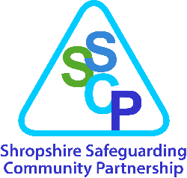

Shropshire Child Exploitation Risk Assessment Tool

NOTE: If completing multiple re-referrals or reviews, please vary the highlight colour of the updated text throughout for clarity.
Before and during completion of this Child Exploitation Risk Assessment Tool please refer to:

- Appropriate Language – Children’s Society Guidance for Professionals
- Shropshire Council Child Exploitation Website
- Shropshire Safeguarding Community Partnership

Action following assessment
- Please ensure any sections marked [mandatory] are completed – if not this adds delay to any action being taken and the assessment will be returned.
- Exploitation Triage is held twice weekly and consists of a multi-agency panel. This risk assessment will be discussed and triage will determine the final risk level based on all available information and will update you about this and any actions/recommendations made.
- Before you continue - discuss and agree with the child and parent:
  - the completed assessment and gain consent to share it.
  - any interventions and support for the child or parents/carers they want.
- If the child isn’t currently open to a Shropshire social worker: Complete a form via the Children’s Services Portal (https://earlyhelp.shropshire.gov.uk/web/portal/pages/home) and add the risk assessment as an attachment. It will be picked up by the Child Exploitation and Missing Coordinator and allocated for discussion at Child Exploitation Triage.
- If the child is already open to a Shropshire social worker: Send the Child Exploitation Risk Assessment to childexploitation@shropshire.gov.uk. It will be picked up by the Child Exploitation and Missing Coordinator and allocated for discussion at Child Exploitation Triage.
- Where parental consent has not been sought or agreed to and there is not clear evidence that the child is being exploited or is at risk of significant harm, the risk assessment cannot be discussed at Child Exploitation Triage.
- Reporting a Crime: If you have documented a crime that has taken place within the CE Risk Assessment, please ensure this matter is reported via 101 or online reporting www.westmercia.police.uk and provide the reference during the assessment.

Child’s forename: | Child’s surname:
DOB: | Address:
Ethnicity: | Gender:
Choose an item.
Disabilities: | Type of plan in place (EH, CIN, CP, CLA):
School/College: | Attendance % if known, and any exclusions:
LCS/EHM Number: | Child’s Mobile Phone number:
Does the child have an NRM? Please include all details here if so, including dates of conclusive/reasonable ground decisions:

Name of professional completing assessment: | Agency:
Email address of person completing assessment: | Date assessment completed:

Has the child given consent to the completion of this assessment and sharing of information? [mandatory] | Have both parents given consent to the completion of this assessment and sharing of information? [mandatory]
  ☐ | Yes
  ☐ | No – please state why not below
  ☐ | Yes
  ☐ | No – please state why not below
Please record any views/comments of the child: | Please record any views/comments of parents (if assessment is being completed/information is being shared without the consent of child/parents, state the reason why):
Please list any agencies that contributed to the completion of this Risk Assessment Tool: | Contact details of parents:

Reason for completing this risk assessment (why now?)
Information needs to include whether there was an isolated incident/issue of concern which triggered the assessment, whether it was a recommendation from exploitation triage, or whether it is a combination of factors, or accumulation of concerns, etc

Child Exploitation Risk Assessment
The diagram below provides a framework to explore the needs of a child or young person who may be at risk of or being exploited. Information from the child, their parents/carer and partner agencies should be used to inform this risk assessment. Please refer to the Child Exploitation Practice Guidance to assist you in its completion.

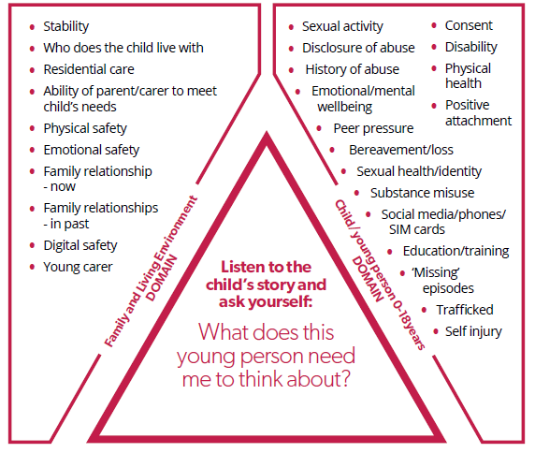
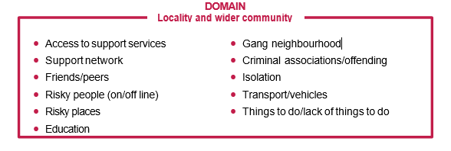
Child/Young Person Domain (link to the above)
What factors about this child identify that they may be at risk of exploitation or are being exploited?
Disclosure of abuse
<delete as required>

History of abuse
<delete as required>

Consent
<delete as required>

Disability
<delete as required>

Physical health
<delete as required>

Sexual activity/sexual health/identity*: *Please note that if under age sexual activity is occurring (<16 years of age), or sexual images are being sent (any sexual images of <18 years of age) this needs to be reported separately to www.westmercia.police.uk. These are assessed case-by-case but in almost all circumstances the Police do not want to criminalise young people.
<delete as required>

Positive attachment
<delete as required>

Emotional/mental well-being
<delete as required>

Peer pressure
<delete as required>

Bereavement/loss
<delete as required>

Social media/phones/SIM cards
<delete as required>

Education/training
<delete as required>

Missing episodes
<delete as required>

Trafficking
<delete as required>

Self injury
<delete as required>

Family and Living Environment Domain (link to the above)
What factors about the child’s family and living environment identify that they may be at risk of exploitation or are being exploited?
Stability
<delete as required>

Who does the child live with
<delete as required>

Residential care
<delete as required>

Ability of the parent/carer to meet child’s needs
<delete as required>

Physical safety
<delete as required>

Emotional safety
<delete as required>

Family relationship – now
<delete as required>

Family relationships – in past
<delete as required>

Digital safety
<delete as required>

Young Carer
<delete as required>

Locality and Wider Community Domain (link to the above)
What factors about the child’s locality and wider community identify that they may be at risk of exploitation or are being exploited?
Access to support services
<delete as required>

Support network
<delete as required>

Friends/peers
<delete as required>

People who may pose a risk to the young person (online/in-person)
<delete as required>

Areas that increase the young person’s vulnerability
<delete as required>

Gang neighbourhood
<delete as required>

Criminal associations/offending
<delete as required>

Isolation
<delete as required>

Transport/vehicles
<delete as required>

Things to do/lack of things to do
<delete as required>

Protective Factors
What strengths and protective factors can you identify that exist and can be used to meet this child’s needs?
What is going well?
<delete as required>

What services or intervention has been tried already – was it effective?
<delete as required>

What has been proven to be effective in reducing the contextual risk for this young person?
<delete as required>
What risk management plans, safety planning, interventions or services have been put in place to address some of the concerns? (e.g. missing trigger plans, GPS sharing, photos with BTP)

Drug and Alcohol Use
The link between drug and alcohol use and exploitation has never been closer – this risk assessment can be used as a direct referral to access support for the young person. Please identify what the young persons’ use of substances has been:
☐ | Vapes | ☐ | ‘THC’ Vapes | ☐ | Alcohol
☐ | Tobacco or ‘snus’ | ☐ | Cannabis | ☐ | Ketamine
☐ | Solvents | ☐ | Prescription Meds | ☐ | Mushrooms/LSD
☐ | Xanax | ☐ | Ecstasy/MDMA | ☐ | Amphetamines
☐ | Cocaine | ☐ | Crack cocaine | ☐ | Heroin/Opiates
If you are unsure of what drugs or slang – try here for further help. Otherwise, please add anything below you feel relevant in regard to drug and alcohol use:

Have you identified potential risks to other children or adults?
If answered yes and there is a risk to other children refer to the Shropshire Exploitation Pathway
If answered yes and there is a risk to adults:
- If an adult with care and support needs refer to the A guide to adult safeguarding in Shropshire | Shropshire Council
Any other adult: refer to Keeping Adults Safe in Shropshire Keeping adults safe | Shropshire Council

Have you identified perpetrators and/or locations that the child/young person frequents?
If answered yes - please report Something you've seen or heard | West Mercia Police . If you suspect a crime has been committed – please see the bottom of this form.

Risk Assessment/determination [mandatory]
Based on the factors you have identified, please indicate your professional judgement as to the level of risk you believe this child faces - tick only one option.
☐ | Indicators the child/young person is vulnerable to child exploitation
☐ | Indicators the child/young person is being groomed or targeted for the purposes of child exploitation (see “Accessing Support” below)
☐ | Indicators the child is being exploited (see “Accessing Support” below)

Please indicate the type of exploitation – tick all that apply.
☐ | Criminal exploitation
☐ | Sexual exploitation
☐ | Forced marriage
☐ | Modern slavery (including trafficking)
☐ | Radicalisation
☐ | Financial exploitation
☐ | Other exploitation to secure benefits or services (please specify)

Rationale: [mandatory]
Please provide a rationale as to why in your professional opinion you have determined the young person to be vulnerable/groomed or targeted/being exploited (delete as appropriate):

Accessing Support
In order to ensure a child/young person is accessing the right support at the right time whilst avoiding repetitive processes for practitioners, it has been agreed with services that this risk assessment will be accepted as a referral to With You and Steer Clear. If you tick, you agree that the young person can be contacted by these services, and you are stating that you have the consent from the young person/parent or carer that the information in this assessment can be shared to third parties.
☐ | Steer Clear knife crime prevention programme - please tick only if there are concerns regarding knives
☐ | With You drug & alcohol service - please note the young person can consent to this without parental permission

- Preventative exploitation support is available through Catch 22 STEPS (Support Through Exploitation and Prevention Service) however practitioners will need to refer the young person through their online form manually. Please be aware that there are criteria for referrals.
- West Mercia Youth Justice Service offer prevention programmes for young people who are at risk of criminal behaviour. Please contact childexploitation@shropshire.gov.uk for a form.

Consent for Social Work Assessment [mandatory]
If the young person is assessed as MEDIUM (groomed and targeted) or HIGH (being exploited) then referrer needs to ensure that the parent, carer or guardian consents to a Social Work Assessment (Section. 17)
☐ | I [referrer] can confirm the parent, carer or guardian has given explicit consent to be contacted for the purposes of completing a S.17 Social Work Assessment if required.

