If this e-mail is not opening properly then you can View it in your browser
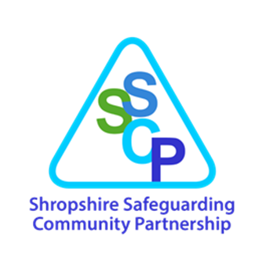


Welcome to the 14th edition of the SSCP Business Unit communication update! We thought it would be better, rather than sending several separate e-mails that we try and combine them all together into an easily digestible update. Please take a moment once you have finished reading to share this update with your colleagues and that you can sign up to the SSCP mailing list through the website.
Contents
- Maternity and Neonatal Voices Partnership: Infographics available for professionals
- Joint Training Opportunities
- Interactive Webinars – Learning from Case Reviews in Shropshire
- Learning from Two Tragic Deaths in Shropshire Families - In Person at Guildhall
- Children’s Portal-Going Live 9th February 2026
- Adoption Plus: Training Opportunities
- NWG Child Exploitation Annual Conference- Thursday 5 March 2026
- Public Lecture: Making Child Protection Work-Professor Harry Ferguson
- 7 minute brief: Domestic Abuse and links to “suspected victim suicides.”
- Telford & Wrekin Safeguarding Partnership (TWSP) Training Available
- Shropshire Early Help Update-January 2026
- Healthwatch Shropshire-Spotlight Report
- Train the Trainers-Day 1 March 4th 2026

Maternity and Neonatal Voices Partnership: Infographics available for professionals
The project was led by researchers at Nottingham University and was funded by NIHR and The Salvation Army.
- The infographic entitled ‘If you’ve experienced control, exploitation, trafficking, or abuse, this could be modern slavery. Do you need maternity care and support?’ is for pregnant women and mothers who are survivors of modern slavery
- The infographic entitled ‘Are you a healthcare professional caring for pregnant women or mothers who have experienced control, exploitation, or abuse? This may include people affected by modern slavery.’ is for healthcare professionals who provide care during pregnancy, labour, and birth and the early weeks after birth
- The infographic entitled ‘Are you a third sector worker supporting pregnant women or mothers who have experienced control, exploitation, or abuse? This may include people affected by modern slavery.’ is for staff in Third Sector organisations who provide support to survivor mothers
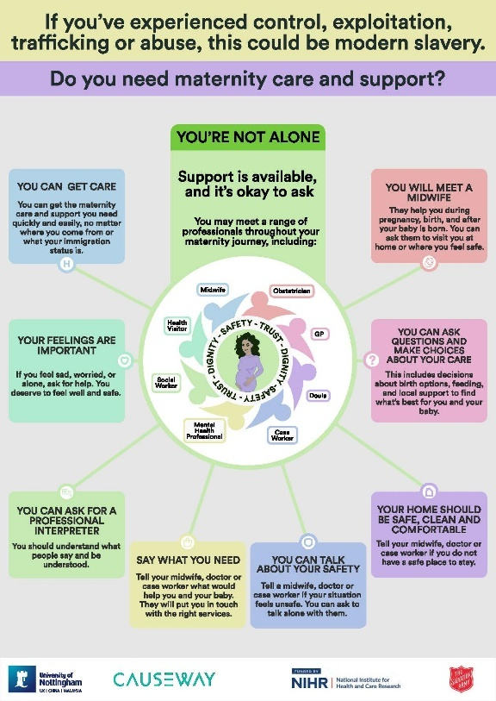
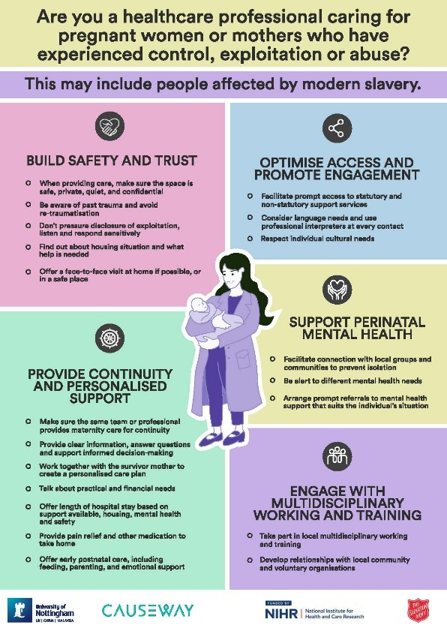
The infographics have been developed from the findings of their research and have been informed by the experiences of a wide range of stakeholders including survivor mothers, Third Sector and maternity professionals. Please feel free to share widely in both digital and printed formats. If the infographics could be made available through your webpages, newsletters, mailing lists, social media and training resources for dissemination and please let Sara know how and where these have been integrated/shared by emailing this information to sara.borrelli@nottingham.ac.uk.
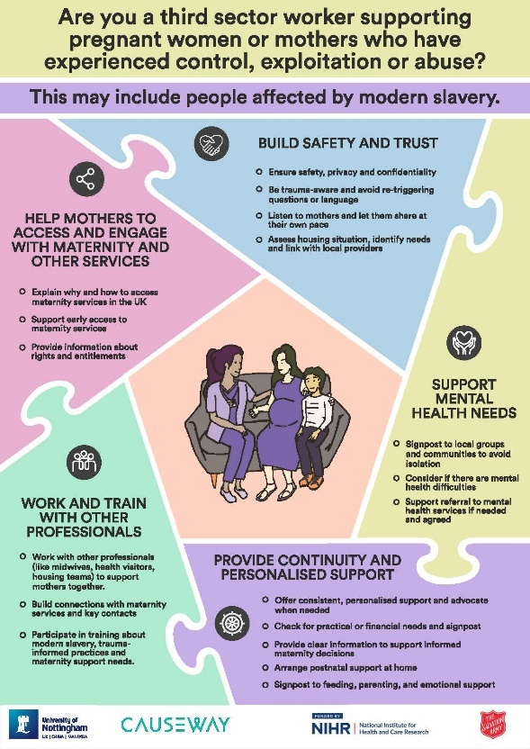
Joint Training Opportunities
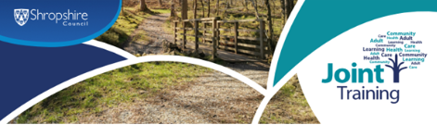
The following courses have been announced by Joint Training – follow the links below for more information and to book your place.
- Safeguarding Adults Awareness
- Safeguarding Children and Young People for Managers
- Domestic Abuse and the Impact on Children and Young People
- Introduction to Early Help and Thresholds
- Professional Curiosity: Putting into Practice
- Safeguarding Children: Raising Awareness in Safeguarding and Protecting Children
- Substance Misuse within our Community: an Introduction
- Understanding Substances and their Effects on the Family
- Suicide First Aid: Understanding Suicide Intervention
- Suicide Prevention in our Communities
- Understanding Trauma and the Principles of Trauma Informed Care

Interactive Webinars – Learning from Case Reviews in Shropshire

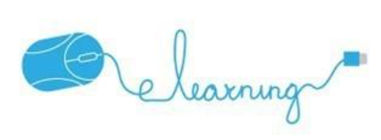

People in Shropshire have died, and it’s important that we learn from these cases and understand what we can all do to prevent further serious harm and deaths.

You are invited to book onto one of our one hour practitioner learning events. There are three different one-hour webinars which will be repeated between January and April 2026, which are intended to increase your knowledge, understanding and how you can make a difference in your everyday practice.

You can click on the links to register and add the date to your calendar, or you can go through our Learning & Development page for information on the subjects of these learning events.

Please book on to these free learning events and share this update far and wide. We look forward to seeing you there.

Understanding Intrafamilial Domestic Abuse Learning Events



These Learning Events are taking place on the following dates:

- Tuesday the 10th of March 2026 - 4:00pm - 5:00pm
- Wednesday the 15th of April 2026 - 9:30am - 10:30am

Domestic abuse related deaths: Homicide and Suicide Learning Events



These Learning Events are taking place on the following dates:

- Tuesday the 17th of March 2026 - 4:00pm - 5:00pm
- Wednesday the 22nd of April 2026 - 9:30am - 10:30am

Domestic Abuse – Why don’t men come forward?

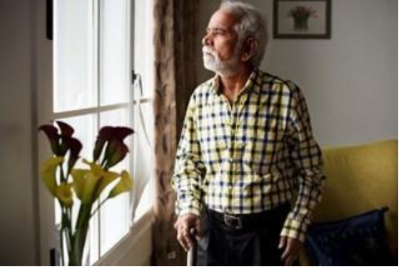

These Learning Events are taking place on the following dates:

- Tuesday the 24th of March 2026 - 4:00pm - 5:00pm
- Wednesday the 29th of April 2026 - 9:30am - 10:30am

The Voice of the Person



The focus of these sessions will be hearing the voice of the person. The aim is to identify and share good practice when the adult or child's voice has been heard, and what we can do differently when we haven’t heard their voices.

These Learning Events are taking place on the following dates:

- Monday the 23rd of March 2026 - 10:00am - 11.30am
- Tuesday the 31st of March 2026 7:00pm - 8.30pm

Learning from Two Tragic Deaths in Shropshire Families - In Person at Guildhall
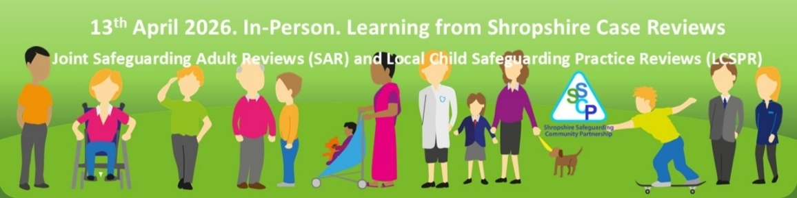

Register now to secure your place and be part of this important discussion on safeguarding practices.

This free, three-hour learning event is open to all frontline practitioners and managers who work with adults, children, and families.

In Person - Guildhall Shrewsbury
Monday 13th April 2026
09:30-12:30

To register, follow this link: Learning from Two Tragic Deaths in Shropshire Families - In Person at Guildhall

We will be sharing the learning from two family case reviews in Shropshire where there was significant harm and deaths. For each of the families a joint Safeguarding Adult Review, and Child Safeguarding Practice Review was undertaken. The focus will be hearing and reflecting on the learning, to increase awareness and knowledge, and to understand how everyone can make a different in their everyday practice.

By working together and sharing information across adult and children's services, we can better protect families and prevent future harm.

Please bring any refreshments that you require for the duration of the learning event. There is an onsite café at Guildhall.

Train the Trainers- Day 1 March 4th 2026

Train the trainers is a 2-day course which will be held on Wednesdays 4th and 11th March 2026, this will enable participants to deliver Raising Awareness in Safeguarding and Protection Children (3 hour) multiagency training to all staff within their own organisation and agencies.
Train the Trainer Day 1 booking - 4th March 2026 - In Person Training
Train the Trainer Day 2 booking - 11th March 2026 - In Person Training
All training resources and handouts are online and are provided by Shropshire Safeguarding Community Partnership Learning and Development Co-ordinator.
Both days must be booked on and attended at Fitzroy academy, Cruckton, Shrewsbury SY5 8PR

Follow the QR Code to access Google Maps for this location
or follow the link here: Directions to Fitzroy Academy, Cruckton, Shrewsbury
This is an in-person course. Once registered on the “webinar” your details will be saved for the course organiser, and you will have the option to add the date to your calendar.
For more information, please review the course information on the SSCP Website:
Train the Trainers (2 Day Course) — Shropshire Safeguarding Community Partnership
Children’s Portal-going live 9th February 2026

The Children's Referral Portal is going live on Monday 9th February.
This Portal will help to streamline communication between families, professionals and Shropshire Council. The public-facing portal allows users to securely submit key forms, this includes Early Help referrals and non-urgent Safeguarding concerns. Please note we are not proposing any changes at this time to the current pathway to targeted early help.
A Professional will need to register once to start using the Portal (not every time) and it is very straightforward to use.
The Portal will enable people to contact Shropshire Council at their convenience, not when our opening hours allow and they will reduce the need for paper-based communication and documentation, which can be prone to errors, delays, and losses.
This Portal will support the Compass and EHAST colleagues to ensure the correct information is gathered as efficiently and effectively as possible, therefore ensuring the decision making based on this info, will lead to suitable, timely help and support for children and young people.
The Portal will be available on the SSCP local procedures pages of the West Midlands Safeguarding Procedures here: Local Guidance
Adoption Plus: Training Opportunities
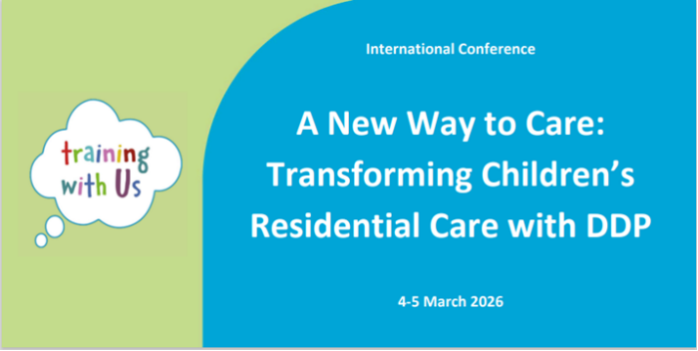

This new international conference will share information about a therapeutic approach that can help promote stability for children and young people.
Hear from experienced residential care leaders who have implemented DDP in the UK and USA about what they’ve done and the impact it has made. You will also hear directly from young people about how DDP has made a difference in their lives, and what safe, trusting care feels like. This conference will explore vital topics like recruitment, staff wellbeing, and leadership — because supporting your team well is the key to supporting children well.
£240
Further information
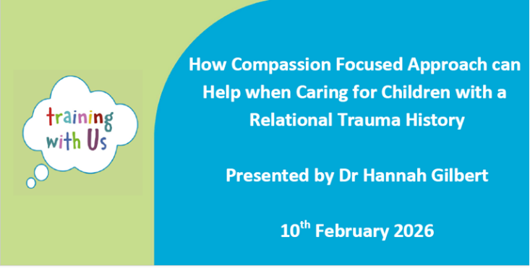
Book your place
Learn how to take a Compassion Focused Approach, when working with or caring for young people with a relational trauma history. Hear from Dr Hannah Gilbert, daughter of Dr Paul Gilbert, founder of Compassion Focused Therapy, how a compassion focused approach can be helpful for parents, carers and professionals dealing with negative impacts associated with developmental and relational trauma.
£90
Further information
Book your place



NWG Child Exploitation Annual Conference- Thursday 5 March 2026

Following on from their successful ‘Where is CSE in 2025?’ conference back on 17 September 2025, NWG are delighted to announce their next NWG Annual Conference on Thursday 5 March 2026.
This will be an online conference via Teams.
Group Booking 10% Discount now available
Book your tickets here: Events - NWG Network

Public Lecture: Making Child Protection Work-Professor Harry Ferguson
Harry Ferguson is launching his new book 'Making Child Protection Work' on the 4th Feb at the University and it is open to anyone who would like to come. For more details and to book a place please follow this link: https://forms.office.com/e/qVLthKFtWH

7 minute brief: Domestic Abuse and links to “suspected victim suicides.”
Please see the refreshed 7-minute brief about domestic abuse and the links to “suspected victim suicides.” Learning from our Domestic Homicide Reviews both locally and nationally has taught us more about the relationship between suicide following domestic abuse. This briefing explains some of the evidence base including the known major risk factors, provides some practical advice and information on resources and support. Can you please share within your organisation, encouraging discussion about the themes and promote it in your own training and newsletters etc.
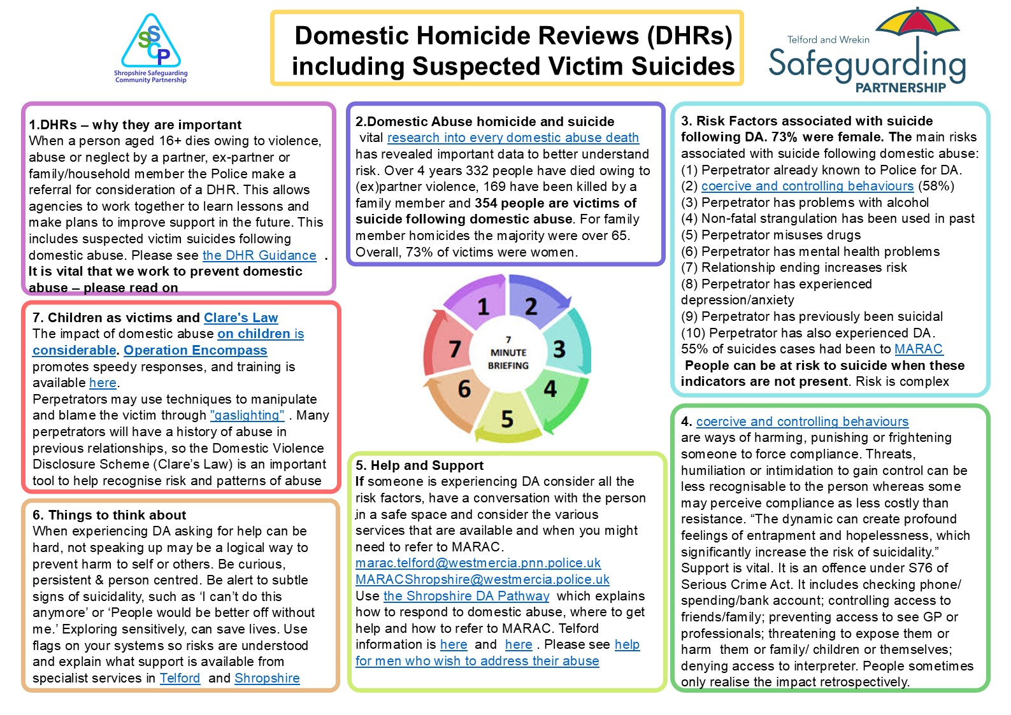
Many thanks for all you are doing to tackle domestic abuse.
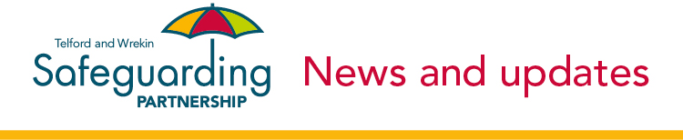
Telford & Wrekin Safeguarding Partnership (TWSP) Training Available

Telford & Wrekin Safeguarding Partnership (TWSP) offers both in-person and online training to all TWSP partner agencies.
The training is free for all professionals and practitioners: you can book your place via OLLIE!
To access the training, you will need to book on with an OLLIE account. If you do not have one, please contact TWSP to set one up: ollie@telford.gov.uk.
For more information about training available, please follow this link: TWSP Training Newsletter: January 2026

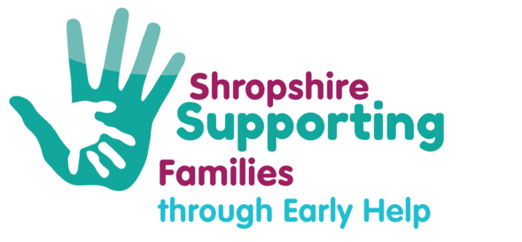
Shropshire Early Help Update-January 2026
For access to the latest Early Help newsletter, please follow this link: Shropshire Early Help Update - January 2026
Healthwatch Shropshire-Spotlight Report
Healthwatch Shropshire have recently published a Healthwatch Shropshire Spotlight Report, “Where do students aged 16+ go first for mental health advice?”.

The full report can be found here: Where do students go first for mental health advice? | Healthwatch Shropshire
Have you got something you want to share?



If there is anything that you would like included the Business Unit newsletter going forward, or something you think should be linked to or shared on the website, then please let us know by e-mailing SSCPBusinessunit@shropshire.gov.uk and please include “Newsletter” or “Website” in the subject of the e-mail.
Thank you for reading and please take a moment to complete the below form on how we can improve both the newsletter, the website or how we communicate with Partners.
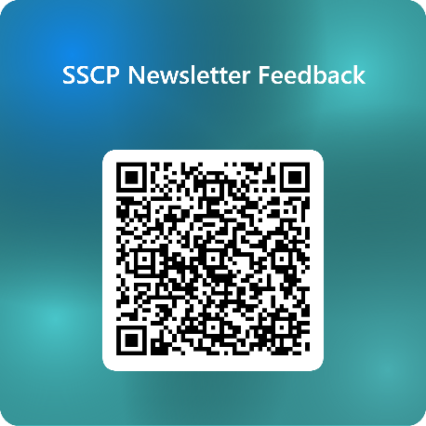
Or you can follow the link here. Please also consider taking a moment to give us any feedback you can on the SSCP website and remember that you can join the SSCP mailing list via the website.
The SSCP Business Unit

